|  |  |  |  |  |  |
| --- | --- | --- | --- | --- | --- |
| Date | 9-Dec-22 | | | Tester Name | Mohammad Yusuf |
| Environment | Penfax - Test | | | Login used |  |
| Operating System | Windows | Version: | Update: | | |
| Software Used | Select Software | Version: | Update: | | |
| Select Software | Version: | Update: | | |
| Release version |  | | | | |
| Title |  | | | | |
| Test Type | Regression | | | | |
| Test Scenario |  | | | | |
|  |  | | | | |
| Expected Results |  | | | | |
| Pass/Fail | Select | | | JIRA# | N/A |

Describe your steps with screenshots:

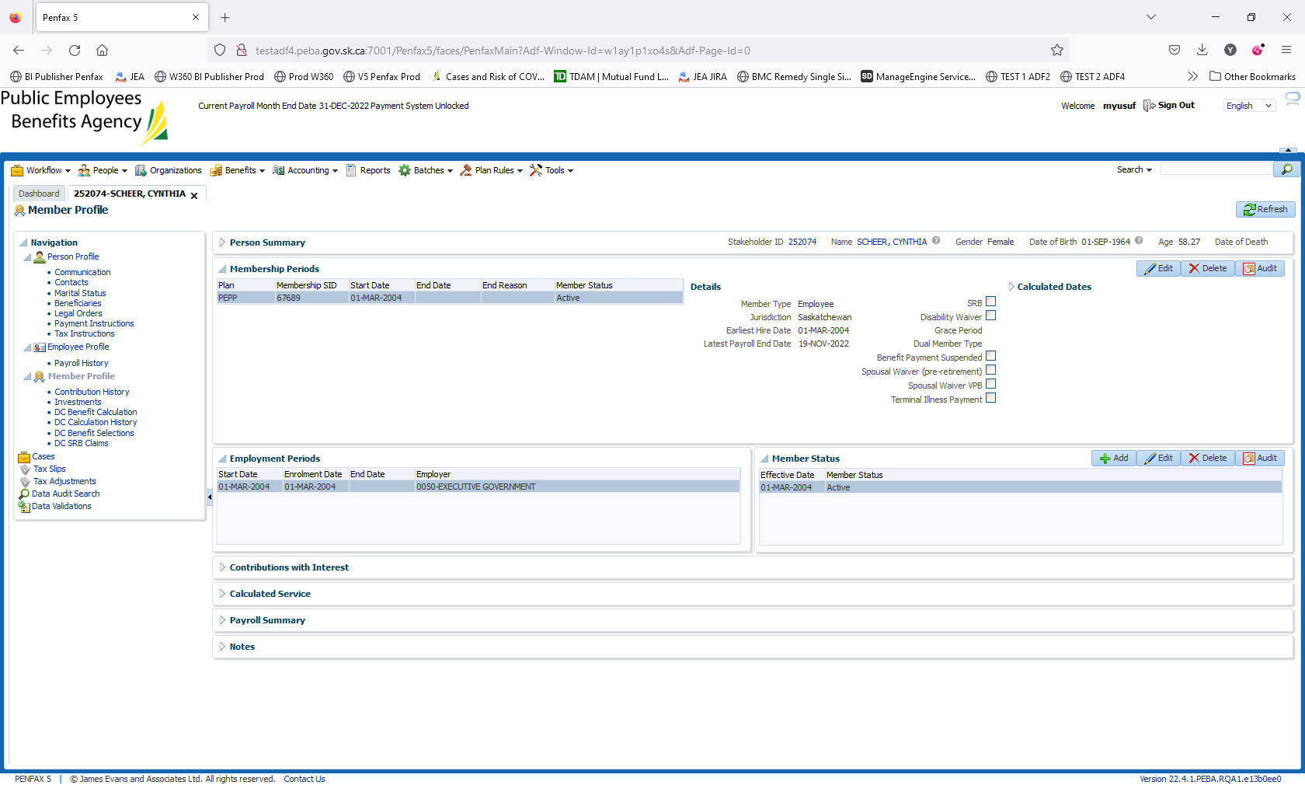

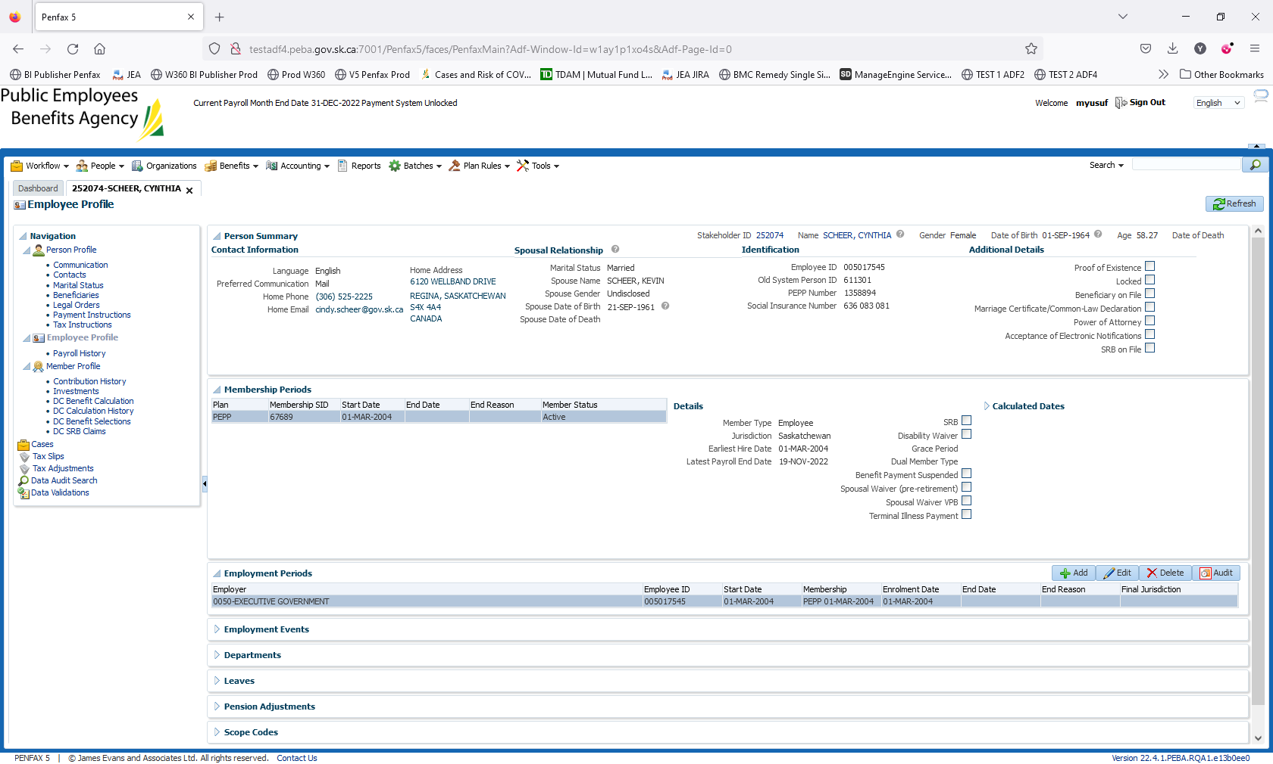

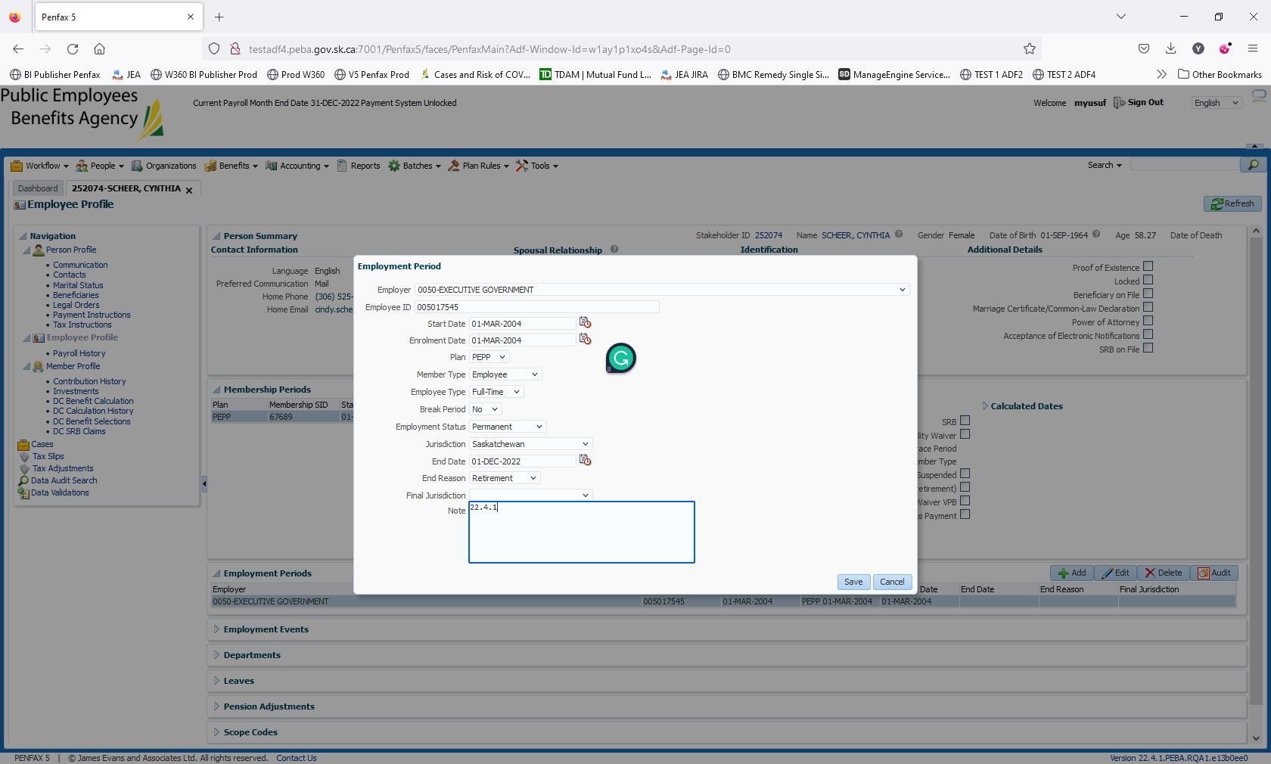

Add retirement date

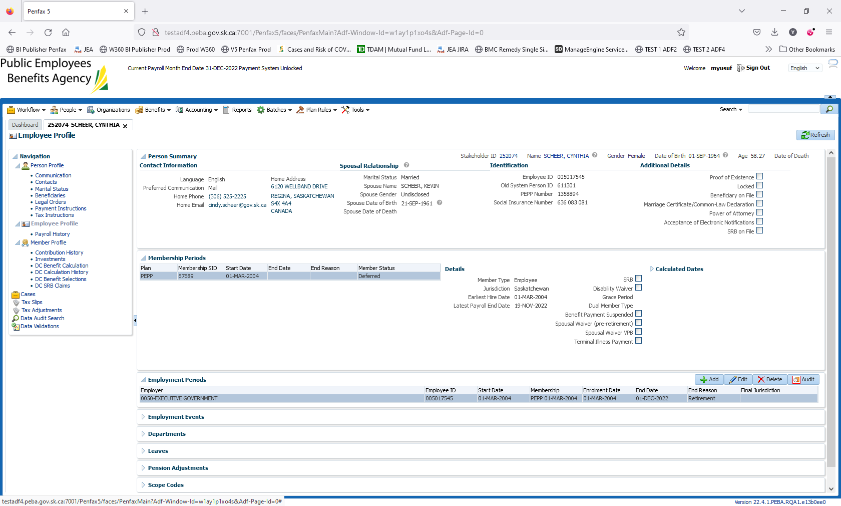

Navigate to DC Benefit Selection

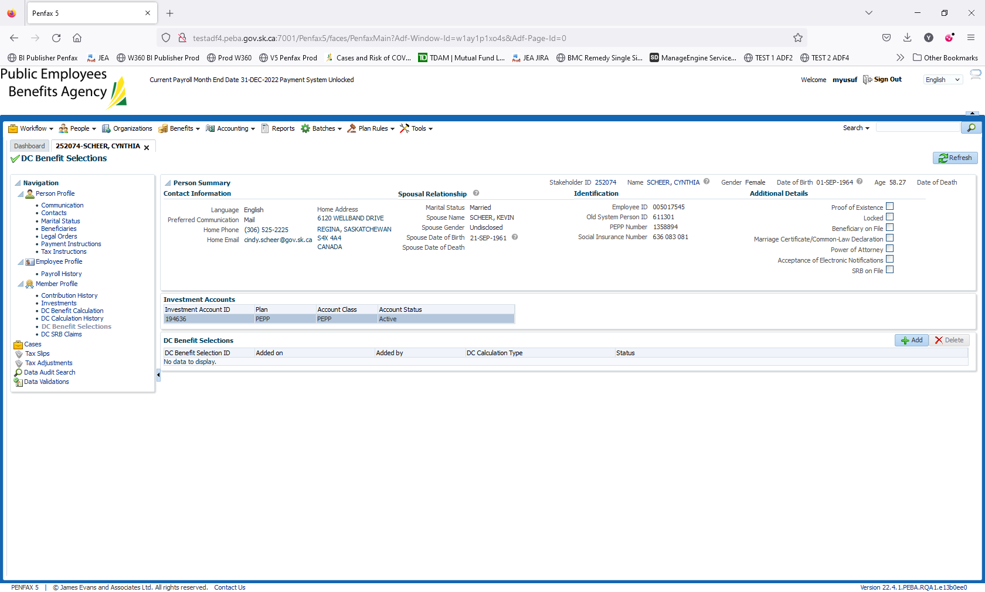

Click on Add

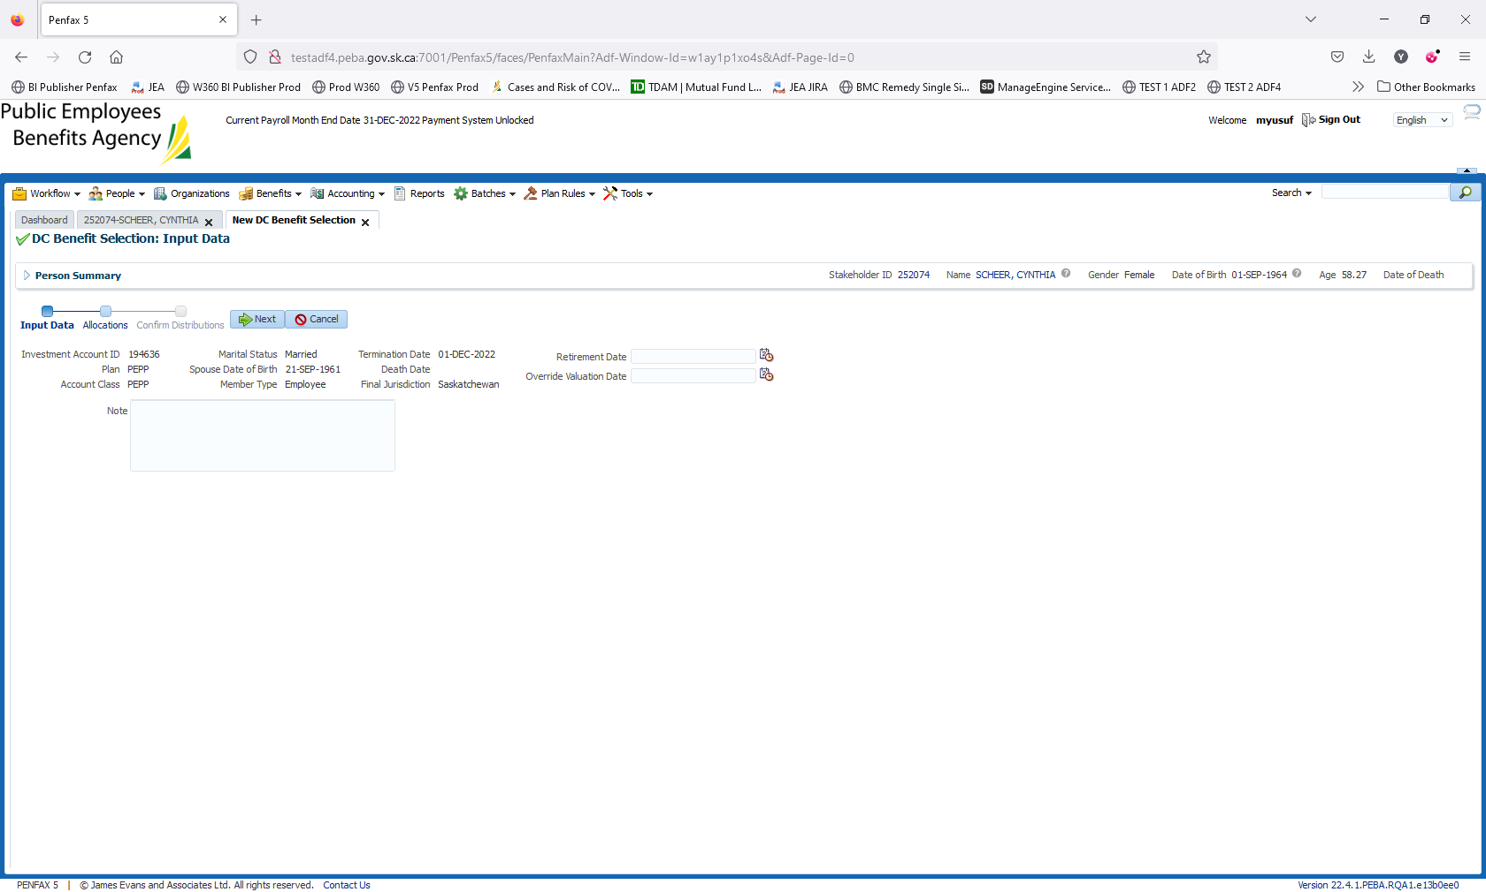

Enter the retirement date. Click Next

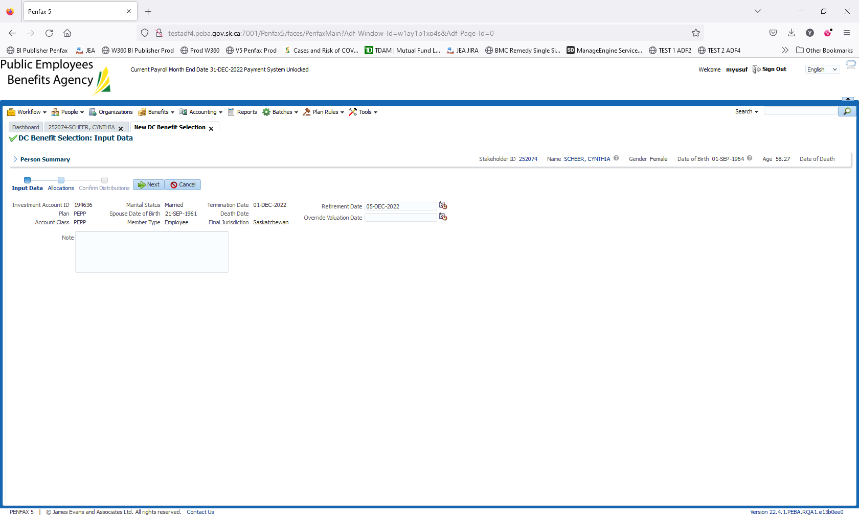

Add allocation

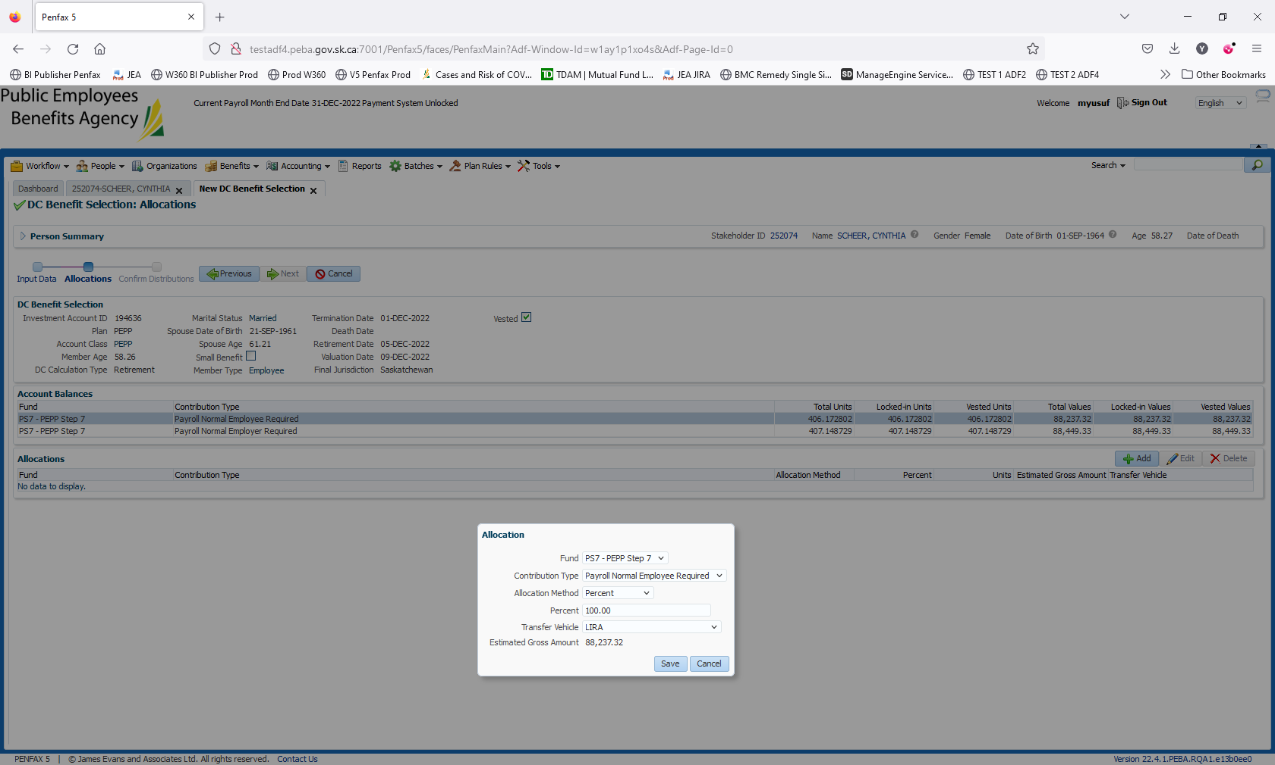

Adding employer and employee contribution type to LIRA (Both Type of contributions)

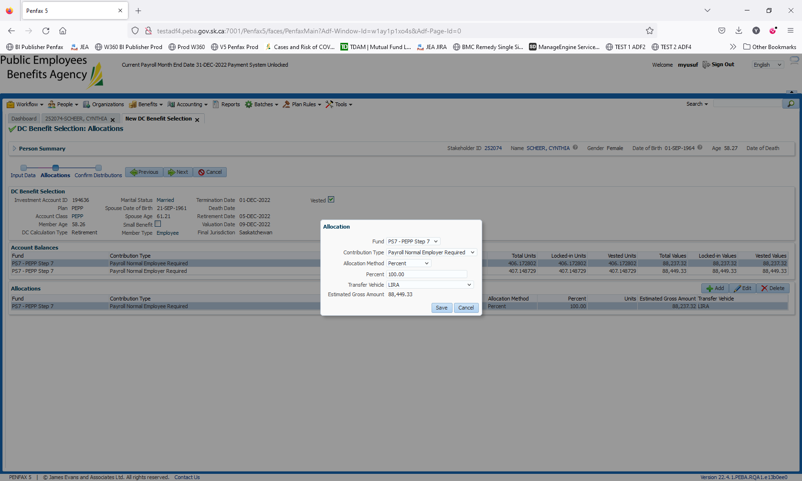

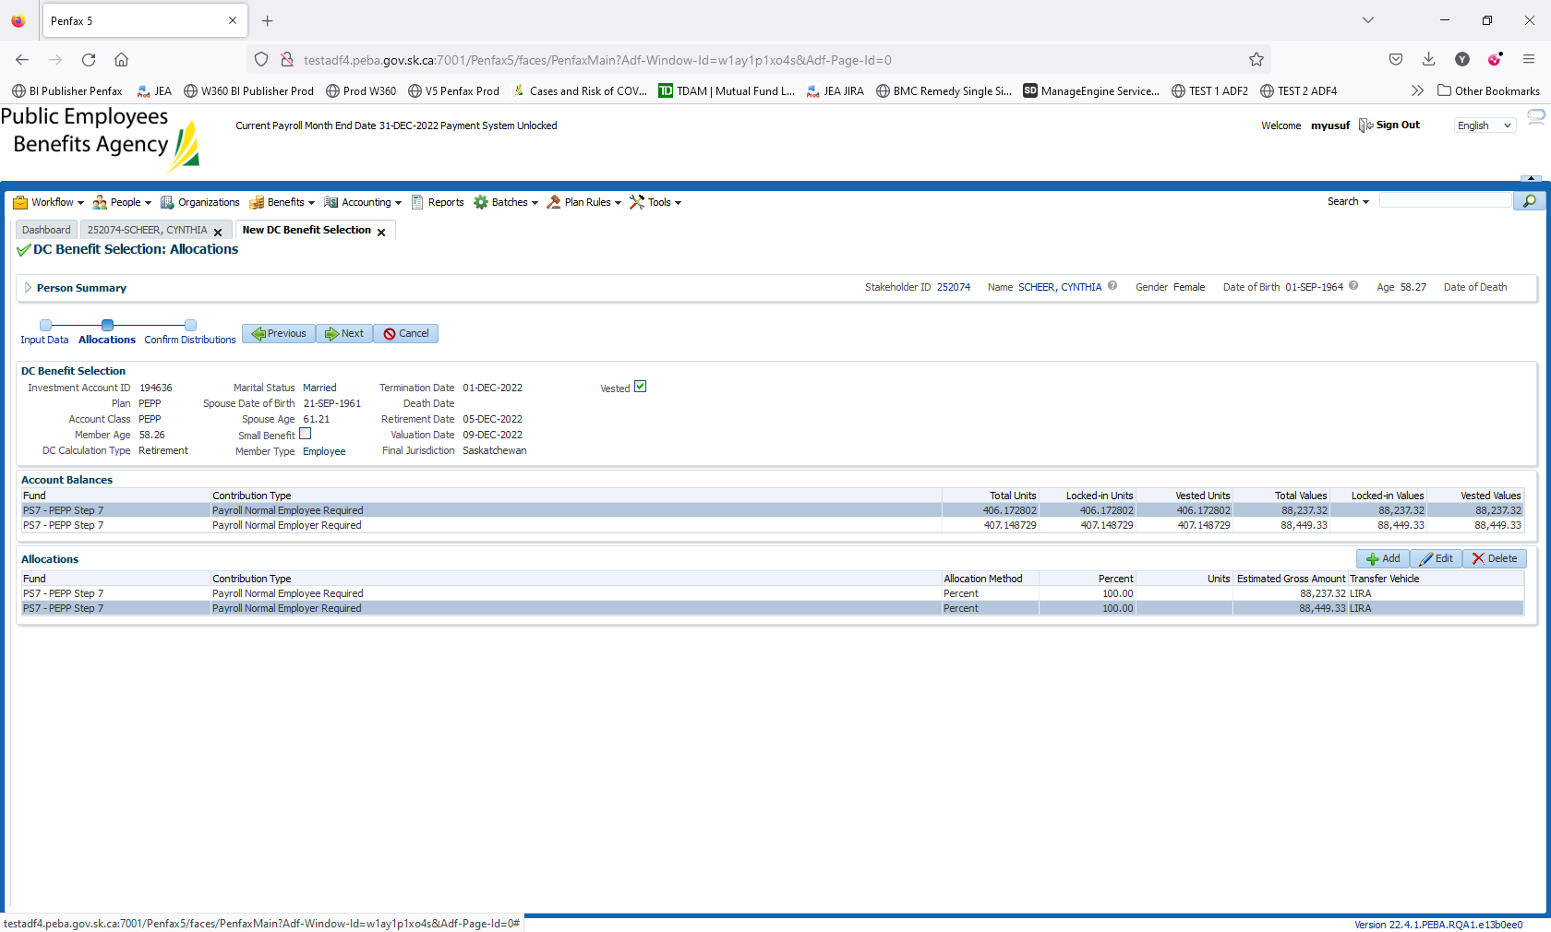

Click on Next

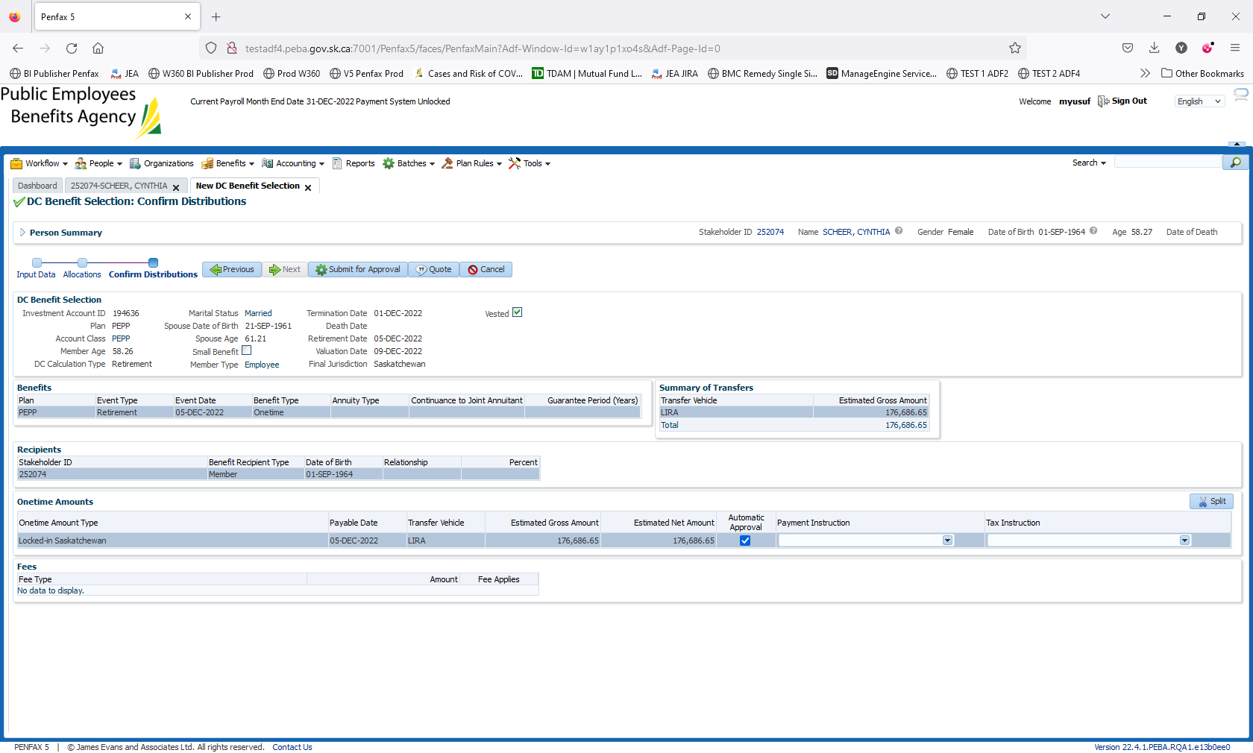

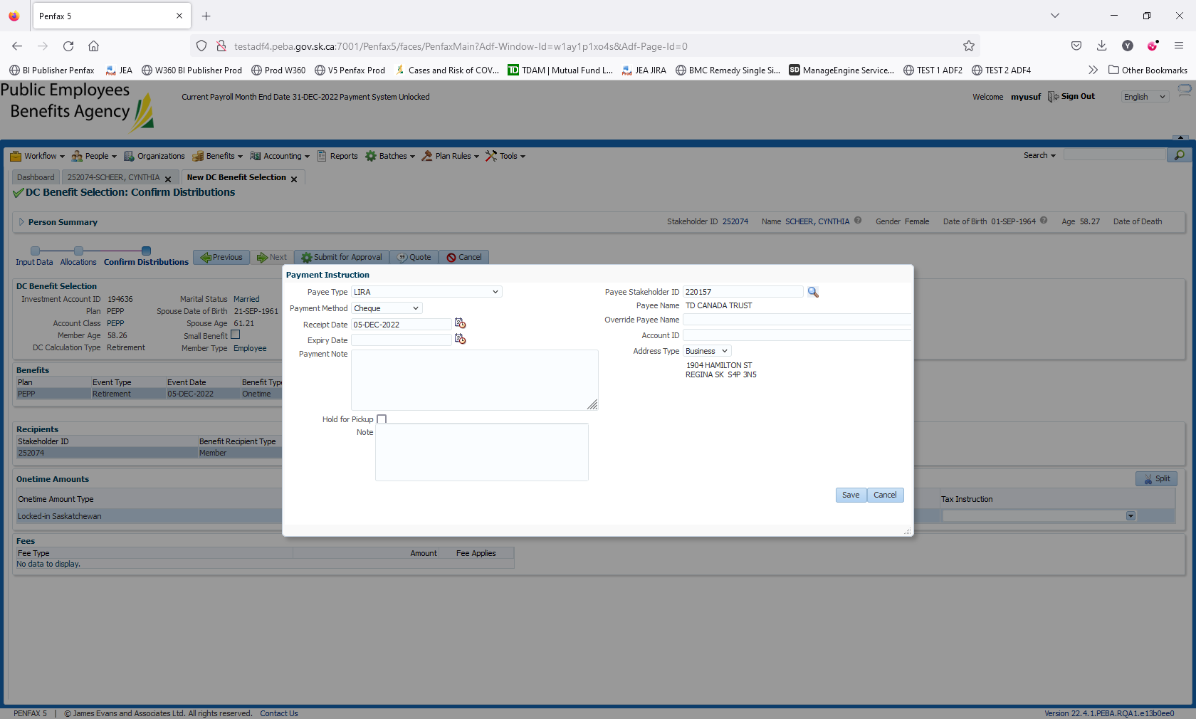

Do not forget to select the payee as LIRA

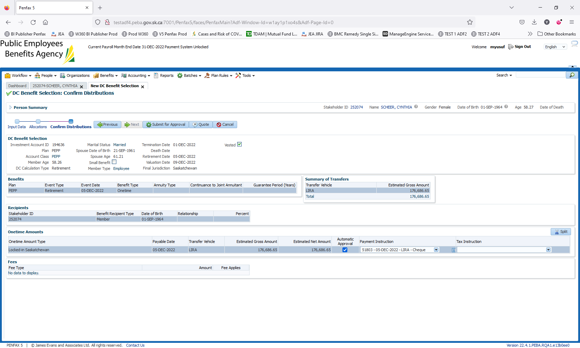

Click on submit for approval

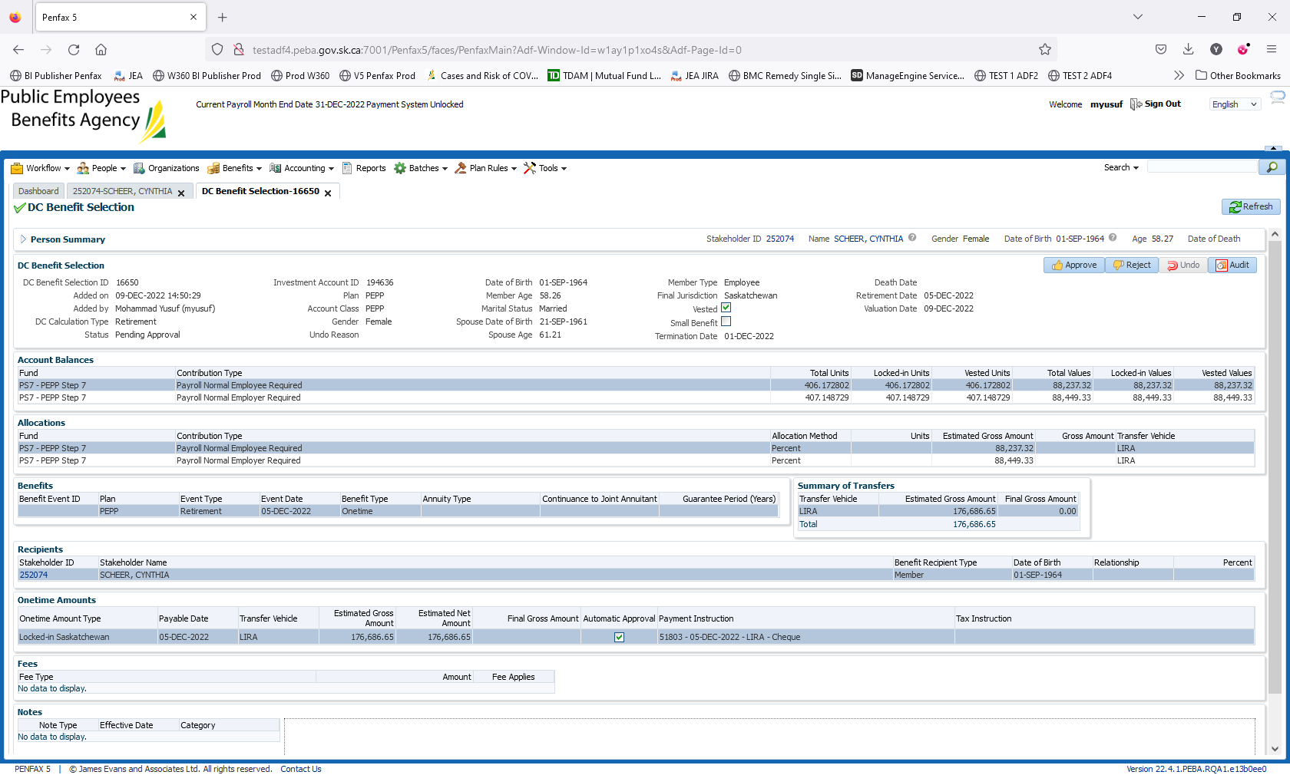

Click on approve

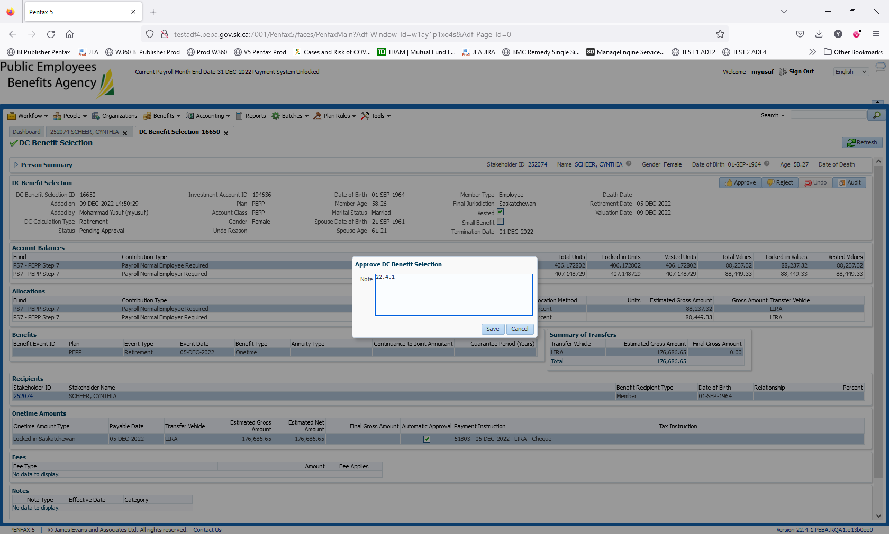

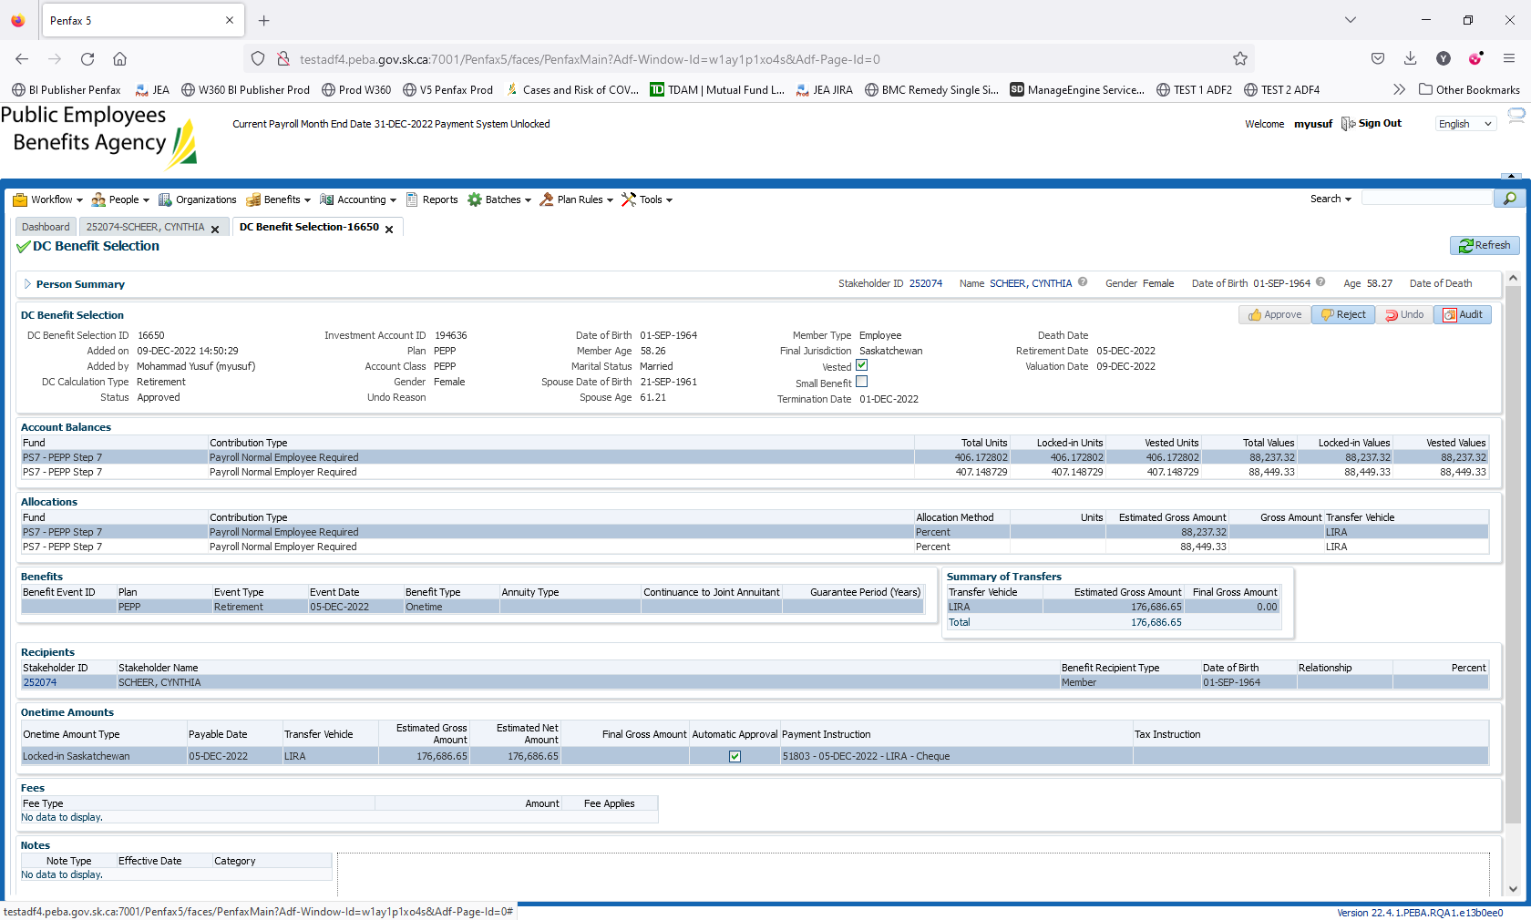

Will have to wait for PIT. Result verification

Day 2: Validation

